徐先生與知名人士

Mr. Xu and celebrities  
徐先生面塑表演現場及媒體報導

Mr. Xu dough sculpture performing live and media coverage  
展覽場地的規劃與想象

Exhibition space planning and imagination  
展櫃實物展示

Showcase physical display  
期待我們未來的作品

Look forward to our future work  
展覽要點概況

Exhibition overview points

辦展單位概況

Profile of the host unit  
媒體廣宣計畫

Media advertising plan

廣宣及互動活動計畫

Advertising and interactive plan

目錄

Contents

宗旨及方向

Purpose and direction  
全球巡展推廣

World tour promotion  
全球巡展的計畫

World tour plan

展覽預期效果

Exhibition the expected results  
中華面塑藝術展領銜創辦人

Chinese led the founder of dough sculpture art  
中華面塑藝術展主創人

Chinese dough sculpture creative people  
作品集

Portfolio

核桃面塑系列作品

Walnut dough sculpture series  
西遊記面塑系列作品

Journey to the west dough sculpture series  
紅樓夢面塑系列作品

Dream of Red Mansions dough sculpture series

水滸傳面塑系列作品

Outlaws of the Marsh dough sculpture series

三國演義面塑系列作品

Romance of the Three Kingdoms dough sculpture series

嬰戲圖面塑系列作品

Children playing dough sculpture series

吉祥人物面塑系列作品

Mascot dough sculpture series

老北京面塑系列作品

Old Beijing dough sculpture series

唐朝御宴圖面塑作品

Tang Imperial Feast dough sculpture works

元朝御宴圖面塑作品

Yuan Imperial Feast dough sculpture works

大觀園面塑作品

Grand View Garden dough sculpture works  
江南水鄉面塑作品

The Jiangnan region of rivers and lakes dough sculpture works

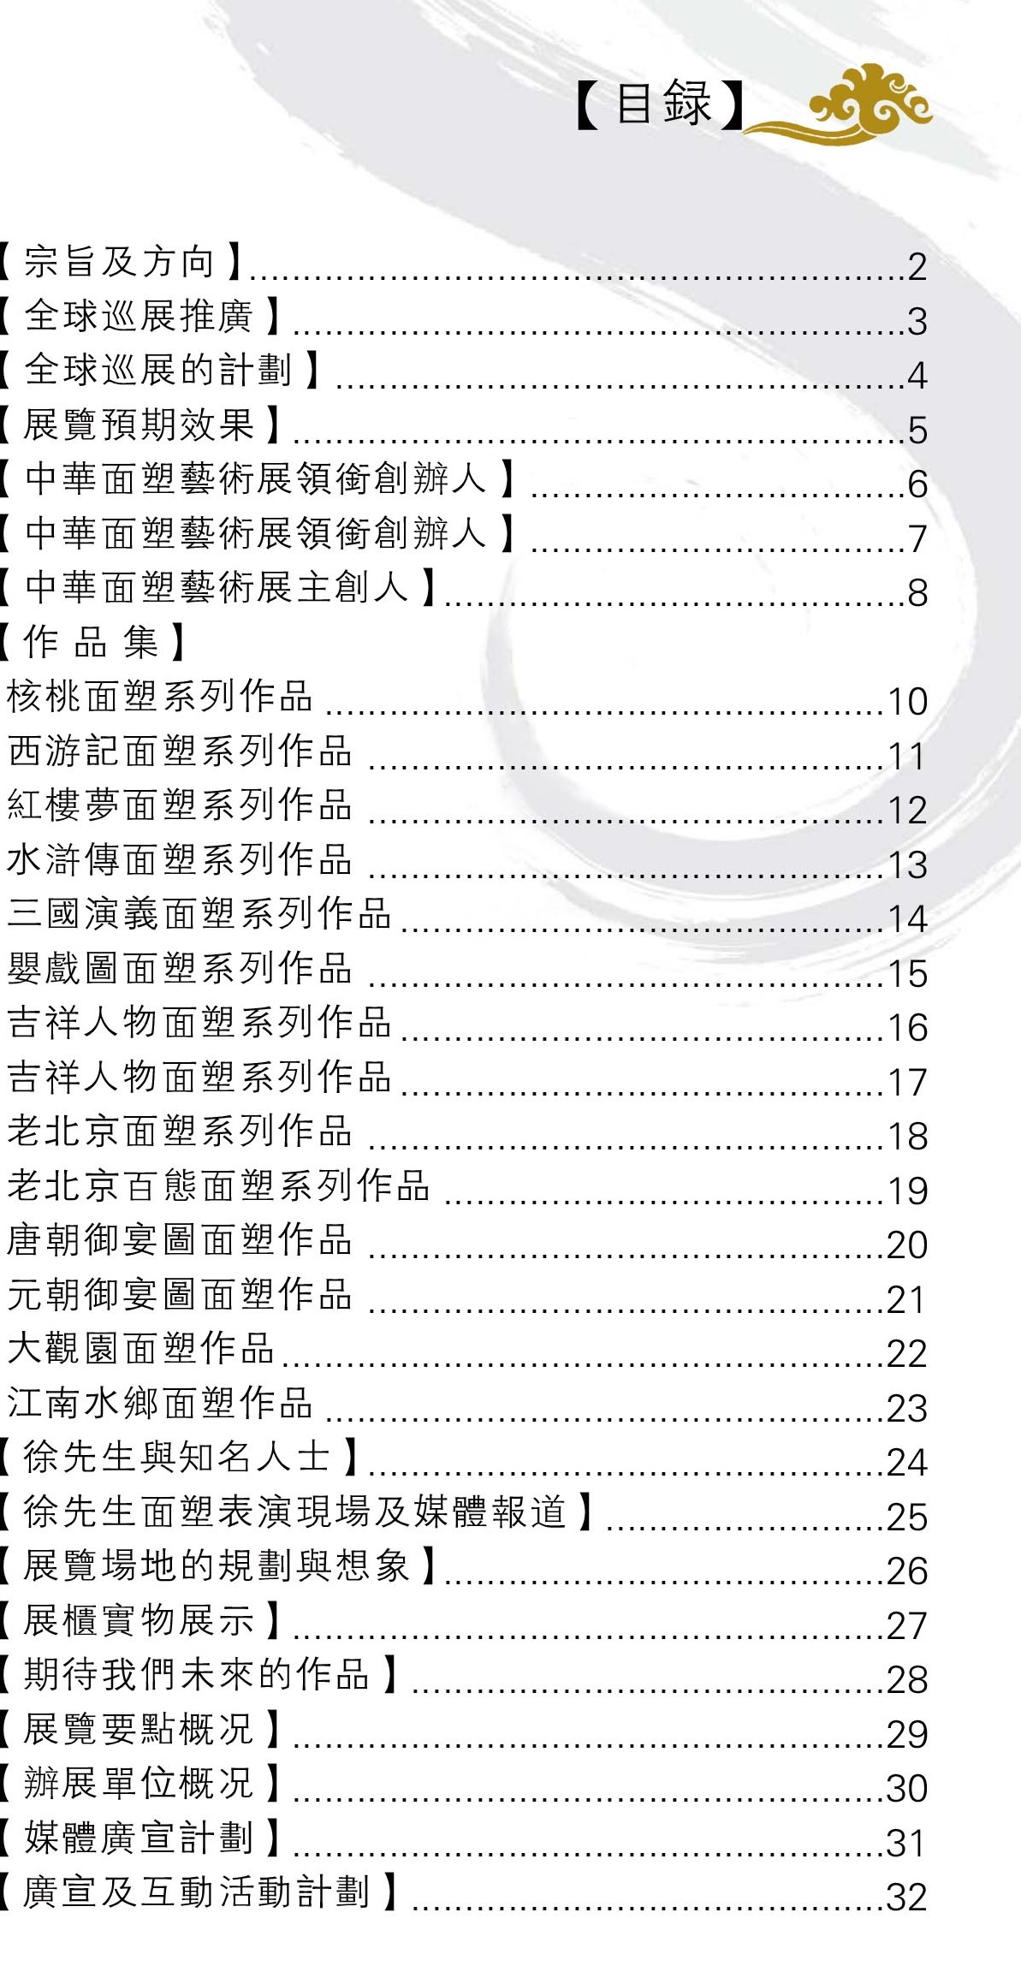

World tour promotion

Director Mr Foo Loke Kee collaborates with Mr. Xu Shiying for dough sculpture art world tour exhibition activities. And running and worked tirelessly to this goal. They hope for the future of the Chinese stunt can spread around the world, but also to various countries and regions of the artist group to carry out technical exchanges and friendly.

Held in the dough sculpture art exhibition process,

Director Mr Foo Loke Kee and Mr. Xu Shiying

will choose more suitable place to set up a dough sculpture themed art museum, so that the skills and work will soon disappear permanently preserved and handed down.

Art exhibition will tour Chinese dough sculpture process and visibility educational, cultural, artistic and relevant government departments to promote, enable our exhibition in the industry both inside and outside and related areas、related industry is more influential. We will use the method of professional exhibition, advertising professional, professional production team to promote our work, let more people enjoy unprecedented dough sculpture art, strive for the cooperation with our partners to bring economic and visibility of earnings!

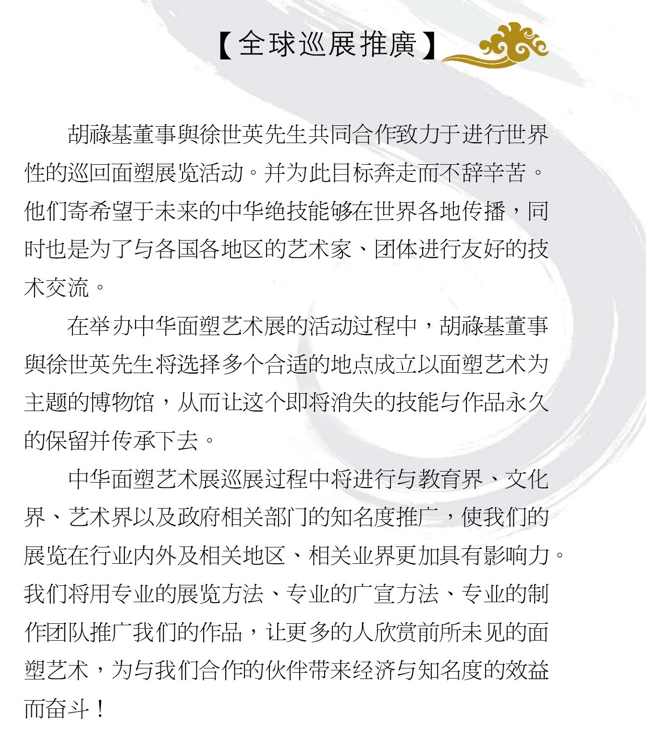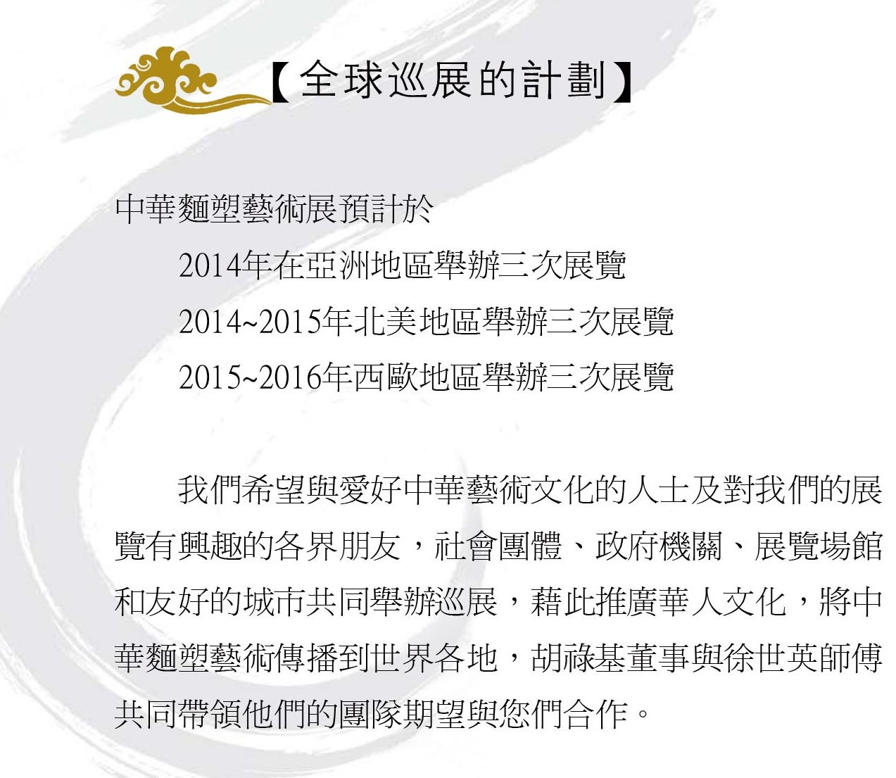

World tour plan

Chinese dough sculpture art exhibition is expected to be  
2014 held three exhibitions in Asia  
2014~2015 held three exhibitions in North America  
2015~2016 held three exhibitions in Western Europe

We hope that with the Chinese culture and art lovers and we are interested in the exhibition of friends from all walks of life, social organizations, government agencies, exhibition venues and friendly city co sponsored tour,

aim to promote Chinese culture, the dough modeling art spread all over the world,

Promote Chinese culture thereby; the dough sculpture art spread all over the world, Foo Loke Kee director and master Xu Shiying co led their team look forward to working with you.

Exhibition the expected results

This exhibition is long-term exhibitions; each exhibition venue for the extension from 3 months to 6 months long, the expected local audiences will reach one hundred and fifty thousand to three hundred thousand people. We will hold a press conference at the exhibition before the start of warm-up activities. The opening ceremony will invite celebrities, famous groups and sponsored enterprises and government officials to address the ribbon, invited a large number of media journalists tracking reports. The art exchange activities in the exhibition process, charitable donations, interactive and educational activities, art and exhibition peripheral products selling, invited entertainers who visited the scene to add to the fun, invite government officials, tourism officials and national and consular officials visit. Cooperate with various media units all-round coverage of this exhibition trends. It is expected that the exhibition publicity effect is ideal, can reach the exhibition area caused a sensation effect, in order to extend the dough sculpture art exhibition and sponsorship visibility and influence to.

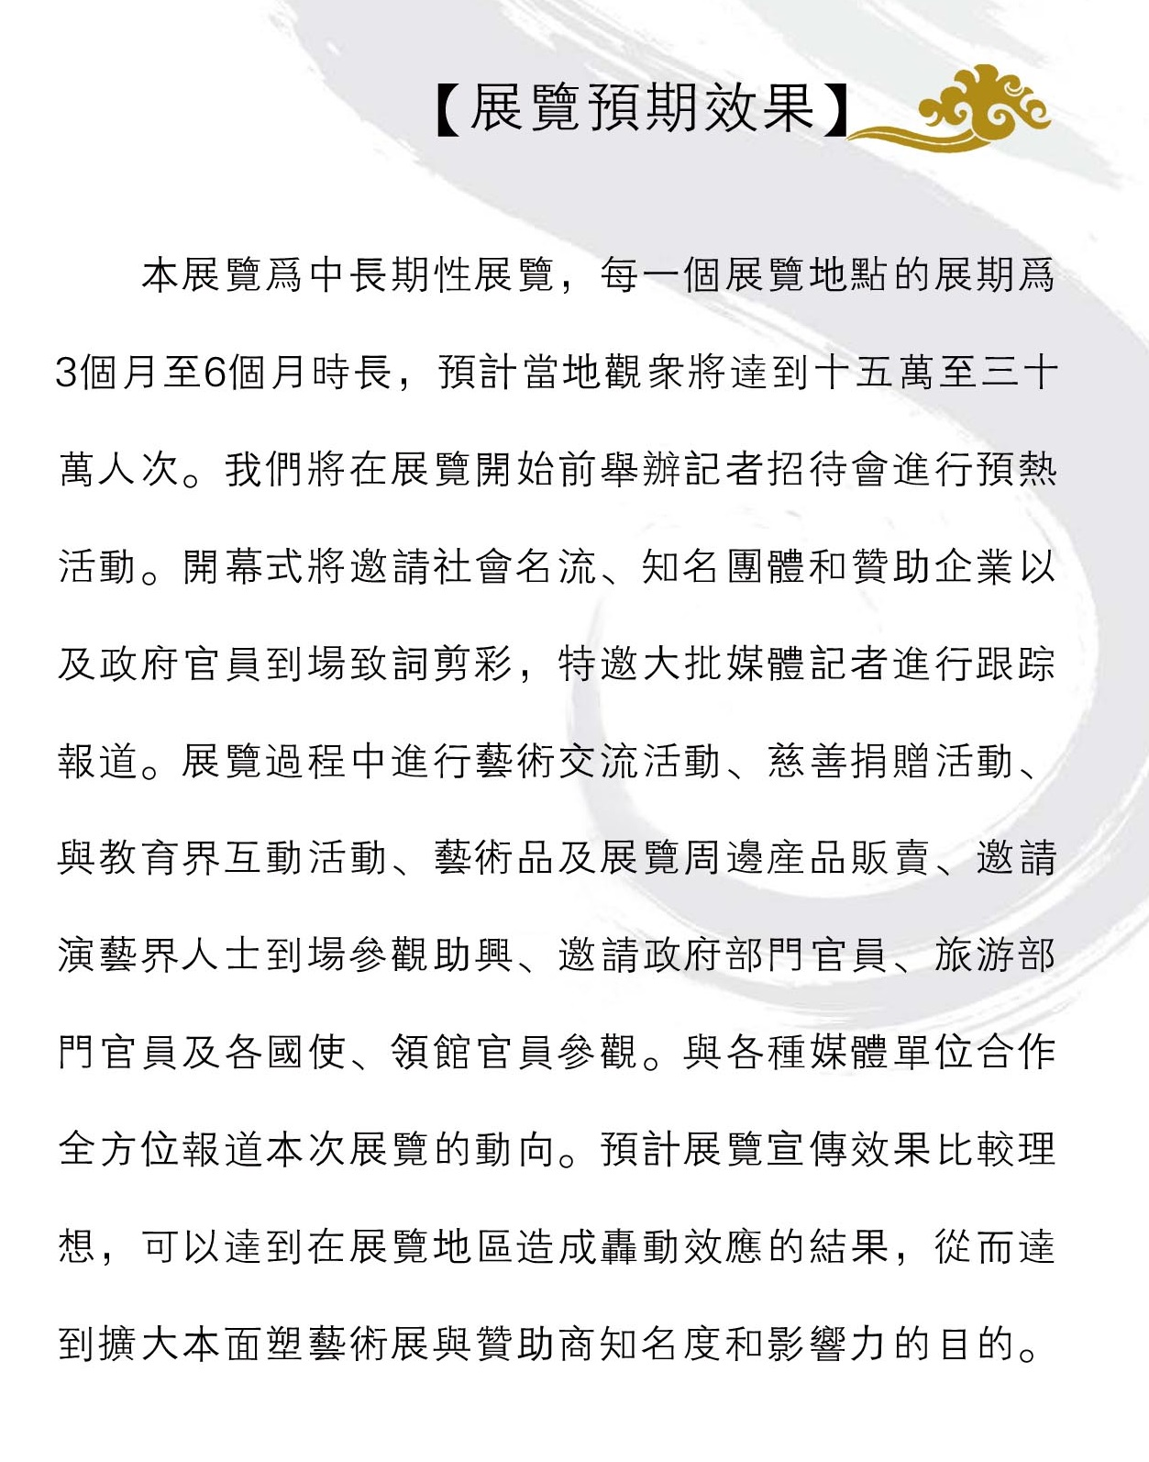

Chinese led the founder of dough sculpture art

Mr Foo Loke Kee

Chinese led the founder of dough sculpture art

His childhood love of Chinese culture, has a strong interest in the arts, because of a fortuitous opportunity in an art exhibition in Malaysia to meet Master Xu Shiying, shock from the first glimpse of dough sculpture works of art director Hu Luji was surprised, art, and is deeply fascinated by Chinese culture, and then begin to explore the mystery of dough sculpture art and Chinese culture, in the process; he had a dream to carry forward the Chinese culture and art. Keep on carving Mr Hu through discussion and exchange many times with Mr. Xu, finally make the dissemination of culture and art to the world's plan.

But such a large-scale exhibition, in the development process will be a lot of difficulties and problems, fortunately to meet with Mr. Wu Junde Taiwan dough sculpture artist’s help, combines China, Malaysia and Taiwan, the power of the three parties and provide relevant information and channel, contribute to Chinese dough sculpture art cultural promoting continued.

